2850 Airport Road
La Crosse, WI 54603
(608) 789-7464
PERMIT
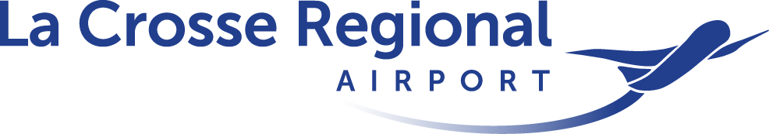

FLYING CLUB… ….......

A) THIS SECTION TO BE COMPLETED BY APPLICANT IN INK…………………………………………………...…….
Legal Name of Flying Club

Current Mailing Address

City |  |  | State |  | Zip
Primary Point of Contact |  | Daytime Phone |  | E-Mail Address
Current AOA Badge Number |  | T-Hangar Number/Hangar Address
Reason For Application? | New Permit Renewal Permit: Original Permit Number ______________________
Permit Checklist --Copies Provided of: | Charter & By-laws/Operating Rules of Club Articles of Association /Non-profit verification  Membership Roster Number & Type of Aircraft Proof Ownership is Vested in Club  List of flight instructors and/or mechanics authorized under this Permit
Insurance Provider | Insurance Limits & Certificate
B) PERMIT ASSURANCES……………………… …………………………………….…......…
As a permitted Flying Club at the La Crosse Regional Airport, _______________________________________ (the Club) agrees to indemnify and save harmless and assume the defense of the City of La Crosse (City), its agents, employees, and officials, from and against any and all liabilities, damages, expenses, causes of action, suits, claims or judgments; and to pay all attorneys’ fees, court costs, and other costs incurred in defending such claims, which may accrue against, be charged to, be recovered from or sought to be recovered from the City, its agents, employees or officials by reason of or on account of damages to the property of, injury to, or death of, any person arising from activities of the Club, at the La Crosse Regional Airport, including acts of omission.

The Club further assures that it will maintain at all times adequate public liability and property damage insurance in sufficient amounts as hereinafter promulgated by the State of Wisconsin to protect its activities and the City from legal liabilities resulting from this activity. The Club shall provide the City of La Crosse a certificate of insurance listing the City of La Crosse as additionally insured without demand and prior to commencing activities under this permit. During the course of its activities as stipulated by this permit, the Club shall ensure that all federal, state, and local statutes, rules, and regulations shall be complied with at all times.

The Club further assures that it will not offer or conduct commercial aeronautical activities including, but not limited to, charter, air taxi, or rental aircraft operations and at no time shall the club hold themselves out as a fixed based operator, flight school, or business offering services to the general public. The Club assures that all flight instruction and maintenance activities comply with Airport Minimum Standards and FAA Order 5190.6B. Flight Instructor and Mechanic authorization under this Permit is only valid for the aircraft permitted. Only members of the Club may operate the aircraft. The Club and its members are prohibited from leasing or selling any goods or services whatsoever to any person or firm other than a member of the Club at the Airport except that the Club may sell or exchange its capital equipment.

The Club shall comply with all applicable federal statues and all regulations including, but not limited to, those promulgated by the FAA and TSA. The Club shall comply with all applicable state and local statutes, rules and regulations including, but not limited to, those relating to tax, fire, building, and safety matters. The Club shall comply with all applicable local, state, and federal environmental statutes and regulations including, but not limited to, requirements for the disposal of waste oil and other potentially hazardous substances and for the refueling of all aircraft when authorized.

The club shall provide an updated membership roster, operating rules, aircraft ownership, or a change in non-profit standing to the Airport within ten (10) days of any changes.

It is agreed and understood that any violation of the standards of this permit may result in its revocation and the City of La Crosse reserves the right to terminate this permit at any time for any reason.
Name of Applicant –Primary POC (Print) | Signature of Applicant | Date

C) PERMIT VALIDITY …………………………………………………………..…………...………………….…..…
Issued permits are valid for a period of 12 calendar months from the date of issuance. Permit holder is responsible for submitting a renewal application within 1 calendar month prior to the permit expiration. Non-renewed permits shall be voided and all privileges provided thereunder shall immediately cease.

D) THIS SECTION TO BE COMPLETED BY AIRPORT PERSONNEL ….…....…
Application Process Completed |  |  |  |  |  | Date
Applicants information completed and correct to best of knowledge
Copy of documents submitted and reviewed
Signatures completed
Application fee paid and payment submitted to airport administration office:  Amount $________  Cash  Check #__________  Bill Account________________ |  | New permit $20.00
Insurance certificate provided: Certificate Number _________________________
Aircraft Authorized
Flight Instructors Authorized
Mechanics
Authorized
Permit Issued | Yes By _________________________________________
 | No By _________________________________________
PROVIDE A COPY OF THE COMPLETED PERMIT INCLUDING PERMIT NUMBER TO APPLICANT AS CERTIFICATION OF PERMIT ISSUANCE
Permit Number
Permit Valid From |  |  | Permit Valid To
Permit Terminated On |  |  | Permit Terminated  By

